Free School Meals

Gloucestershire Schools offer Reception, Year 1 and Year 2 pupils a Free School Meal. This is in addition to the Free School Meals service currently offered to pupils whose parents are in receipt of qualifying benefits (shown overleaf).

Research has shown that healthy Free School Meals improve children’s learning and productivity whilst saving parents money. The number of children benefiting from Free School Meals in Gloucestershire has increased significantly over recent years as have the quality of meals and nutritional benefits to the children.

Registering could also raise money for your child’s school
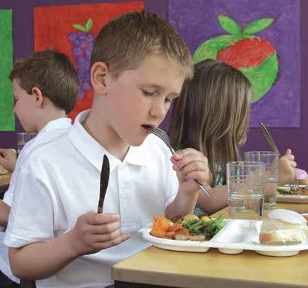
Even if you don’t want your child to receive a meal, you should still

register, so that their school receives as much funding as possible from the Government. By registering you could raise an extra £1320 to help fund valuable support for your child like extra tuition, teaching assistants, after school clubs, music lessons and sports activities.

To do this, please complete the form overleaf if your child will be entering reception, year one or year two in September and return it to Travel Assistance & FSM Team, Commissioning for Learning, Shire Hall, Westgate Street, Gloucester, GL1 2TP. For children in year 3 and above please also send the form to the aforementioned address.

How the information in this form will be used

The information you provide will be used by the school to claim Pupil Premium Funding from Central Government. This is the amount of grant money the school can claim, and is based on the number of children from families receiving the qualifying benefits, as detailed on this form.

It is really important that you complete all the information requested on this form, to help keep Gloucestershire schools as well funded as possible.

Free School Meal Registration Form

Your Full Name: Mr ☐Mrs☐Ms☐Miss☐
First Name: Surname:
Date of Birth:
Relationship to child or children:
Full address:
Postcode:
Telephone number (inc. code): Email address:
Have you recently moved into the county of Gloucestershire ☐
Child/ren previous school:
Please state you National Insurance Number (e.g. AB 12 34 56 C):
Please state your NASS Number (Asylum Seekers):
(The NASS is a 9 digit number, in the format "010234567" where the first four digits should be in the format YYMM.)

Please tick boxes below to indicate which benefit you are entitled to:
Income Support ☐ Income-based Jobseeker’s Allowance ☐ Guaranteed Pension Credit ☒
Employment & Support Allowance ☐ Asylum Seeker Support ☐
Child Tax Credit (not Working Tax Credit) and an annual gross income (as assessed by HM Revenue & Customs) of no more than £16,190 ☐

Working Tax Credit 4 week ‘run-on’- paid for four weeks after you stop qualifying for Working Tax Credit ☐

Universal Credit - Your household income must be less than £7,400 a year (after tax and not including any benefits you get) ☐

Child’s Surname | Child’s First Name | Date of Birth | Year group | Current School

DECLARATION: The information I have given on this form is complete and accurate. Any personal information you give us is held securely and will be used only for the purposes outlined in the privacy notice. In accordance with the General Data Protection Regulation (GDPR) and Data Protection Act 2018 we must inform you of how we use this information for the purposes of Free school Meals, in line with our responsibilities under the Education Act 1996 (s512). For further information on how we use this information please view our Privacy Notice which can be found online at:- www.gloucestershire.gov.uk/privacynotice
Signature of parent/guardian: Date:
**By making this application you are confirming you have parental responsibility for the child/ren above.
If you have any questions about completing this form please call the Travel Assistance & Free School Meals Team on 01452 425390 or email edsupport@ gloucestershire.gov.uk .

