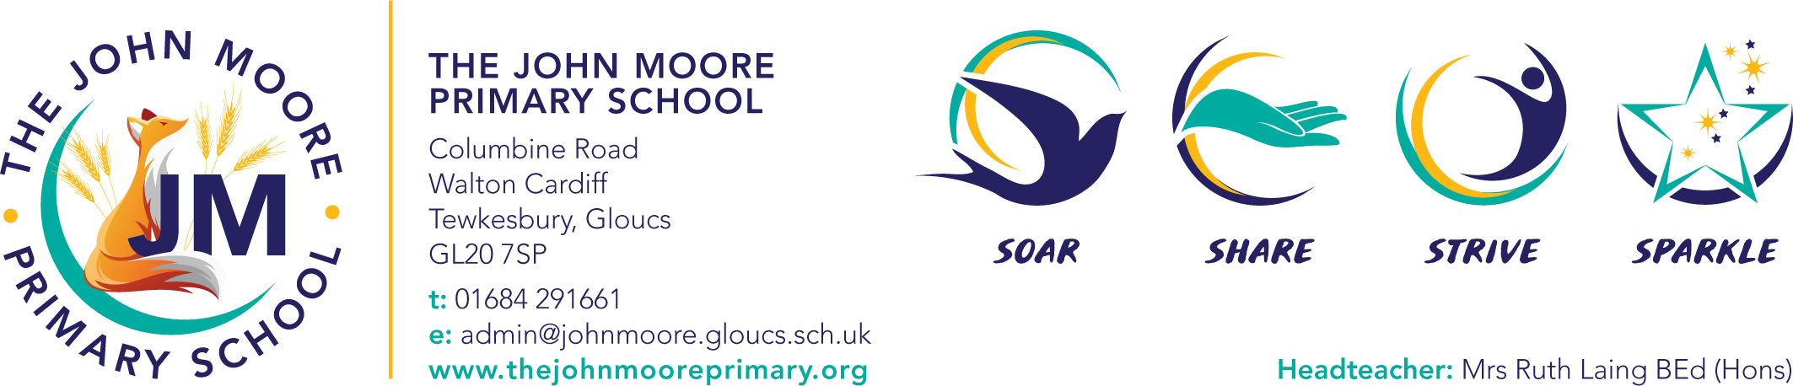
Swimming Offer 2023-24

Children in Years 3 are being provided with swimming lessons at Tewkesbury School where they will be working on building confidence and stamina as well as developing stroke technique. Children will be monitored against their ability to swim 25m by the end of KS2 as a prerequisite of the National Curriculum.

The children will be grouped according to ability (within their class) and will be assessed by a qualified instructor within their group. The swimming instructors will be working towards certain tasks with the children so that they can progress towards this essential life skill.

Children in Years 4, 5 and 6 who have not met the prerequisite of 25m will also be provided with sessions with qualified instructors in groups of 15 in order to achieve this by the end of KS2.

We hope that this information has been useful and if there are any questions regarding the above then please don’t hesitate to contact Mr Howell.

Mr Howell
PE Coordinator

