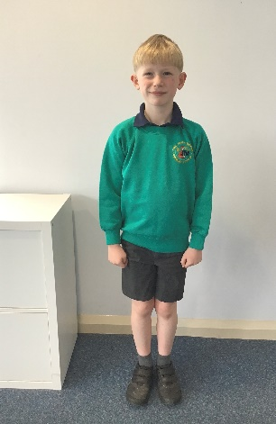

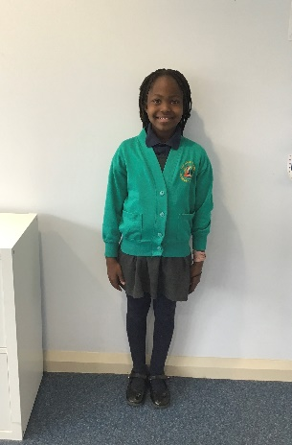**School Uniform**

**What should my child wear to school?**

At The John Moore Primary School we are proud of our eye catching and smart uniform worn by our children which helps to create a sense of identity and belonging.

Please see the enclosed order form to help purchase particular items. All other items can be purchased from shops of your choosing.

The school office has a selection of sizes in stock and is more than happy for you and your child to come and try them on.

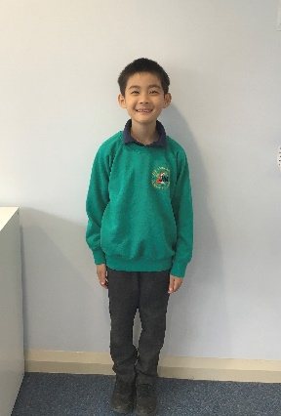The school uniform consists of the following:

* 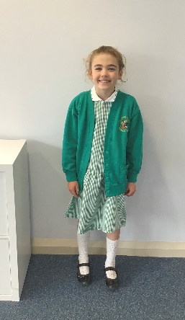Jade green sweatshirt or cardigan both embroidered with the school’s logo
* Navy blue polo shirt embroidered with the school’s logo
* Grey school trousers, shorts, skirts or pinafore dresses
* Green striped or checked summer dresses
* Socks or tights must be worn and either white or grey
* Black sensible shoes

*Please note that trousers should NOT be flared, skin tight, joggers, boot-legged, cargo, combat or skater. Shoes should NOT be open toed or high heels.*

**Jewellery**

Please only send your child to school wearing stud earrings. On PE days please take them out if possible, if not tape will need to be supplied so that your child can cover their earrings. Children are allowed to wear a watch but this will need to be taken off for PE lessons.

**Hair**

Please ensure that all long hair is tied back, this is for the safety of your child. We respectfully ask that all hair accessories are of a sensible size and nature.

Please ensure all uniform is clearly labelled and check regularly that labels are still present and clear.

**PE Uniform**

**What should my child bring to school for PE?**

At The John Moore Primary School we are proud of our smart and practical PE kit that all children wear.

Please see the enclosed order form to help purchase particular items. All other items can be purchased from shops of your choosing.

The school office has a selection of sizes in stock and is more than happy for you and your child to come and try them on.

Please ensure all PE kit is kept in a named PE bag.

The school PE kit consists of the following:

* Jade green T-shirt printed with school logo
* Navy blue shorts
* A jumper, hoody or sweatshirt
* A pair of joggers
* A pair of pumps or trainers

Please supply tape if your child wears stud earrings as they will need to cover them.

